Student Registration

Personal Information
Parent(s) Name: Home Address:

City: Zip:

Home Phone: E-Mail Address:
( ) Dad’s Cell: ( )
Mom’s Cell: ( )

How did you hear about us?
Flyer/Brochure ◻
Other:
Family ◻ Friend ◻
Internet ◻
T-shirt ◻
Sign ◻ Web Site ◻

Swimmers Information (#1)
Child’s Name:
Date of Birth:
Enter corresponding # from Swimmers Ability Chart: #

A
ge:

Male ◻ Female ◻

Prior Swim Lessons: Yes ◻ No ◻

Special Notes: Lessons Requested: ◻ Group ◻ Private ◻ 2 Person Private

Swimmers Information (#2)
Child’s Name:
Date of Birth:

Enter corresponding # from Swimmers Ability Chart: #

Age:

Male ◻ Female ◻

Prior Swim Lessons: Yes ◻ No ◻

Special Notes: Lessons Requested: ◻ Group ◻ Private ◻ 2 Person Private

Swimmers Information (#3)
Child’s Name:
Date of Birth:

Enter corresponding # from Swimmers Ability Chart: #

Age:

Male ◻ Female ◻

Prior Swim Lessons: Yes ◻ No ◻

Special Notes: Lessons Requested: ◻ Group ◻ Private ◻ 2 Person Private

Swimmers Ability Chart
- Child is under 3 and / or never been in a Parent Tot class before
- Child is over 3 and a new swimmer, non-swimmer or scared
- Child will jump in, comfortable w/face underwater & try to float
- Child can float, front glide w/kicking & beginning to use arm pulls
- Child can swim freestyle & attempt backstroke and/or breaststroke
- Has good freestyle w/side breathing & some back & breaststroke
- Able to swim all strokes, needs strength & stoke training

For Office Use Only

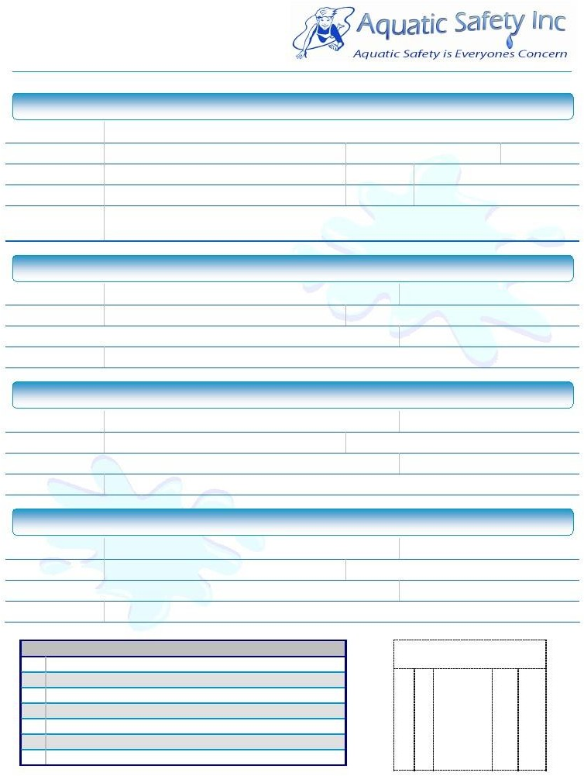
7261 Piute Creek Dr. Corona, CA 92881 (951) 316-8650 AquaticSafetyInc@Aol.com Fax # 1-866-758-9191

Scheduling Request

Scheduling Instructions

We schedule according to a “Session System”. Refer to the 2024 Session Dates below. You may enroll your children in any, or all, of the Sessions over the course of the summer. This form is for your starting Session only. All additional Sessions must be requested on a Session Continuation Form located poolside and available during the middle of each preceding Session. When you are done filling this form out, please return it ASAP via mail, e-mail, drop it off in our mailbox or fax it back to us (Fax # 1-866-758-9191).
- Registration Fee is due in ADVANCE w/ Registration Form: $35 1 Student $60 2 or more Students
- Complete the entire Registration Form, then return ASAP as class space fills fast and are filled on a first-come, first-serve basis.
- Family Registration Fee ($35 or $60) must be paid in advance (cash, check, Venmo, PayPal, CashApp) & returned with this form.
- Check the box by the Session # that you wish to start & next to the days you wish to attend. (e.g., M & W, T & Th, or All 4 days a wk)
- Indicate the time block(s) that you’re available in order of preference. (e.g., 1st Choice, 2nd Choice etc )
- When you check a time box, it indicates that you’re available ANYTIME during that time period!
- The more flexible you are with days (Either/Or) & times (1st, 2nd etc) the better I can match your children up in an appropriate class.
- We will contact you via TEXT prior to the start of that Session to confirm your exact days and starting times.
- Registration Forms may be submitted after the Enrollment Deadline but will be added to classes only if availability exists.
- Students are placed according to a combination of age, ability & comfort. Class levels offered each ½ hour may change based upon demand.
- ** Group Classes are limited to 3 students & ALL classes are 30 minutes long. More advanced classes (Stroke Clinic or Pre-Swim Team) may have more students but, if so, will run longer (45 min or 1 hour) at no additional cost.

IMPORTANT NOTICE: Carefully verify your schedule prior to registering for a Session. There are no “partial month” or “odd day” schedules as well as no refunds or make-up classes for missed lessons.
See Page 3 for Payment Links “QR” Codes and Page 4 for Scheduling & Programing FAQ’s.

Corona Pool
Lesson Request
2024 Session Dates

Days:
☑
- M & W ◻
Either/Or ◻ T & Th
- All 4
Session #
Start Date
End Date
Enrollment Deadline

Times:
- Session 1
- Session 2
- Session 3
- Session 4
- Session 5
- Session 6
9am – 11
11am – 1
3pm – 5 5pm - 7

1 June 3

2* July 1

3 July 8
4* Aug 5 Aug 8 July 26

June 27

July 3

Aug 1

May 24

June 21

June 28

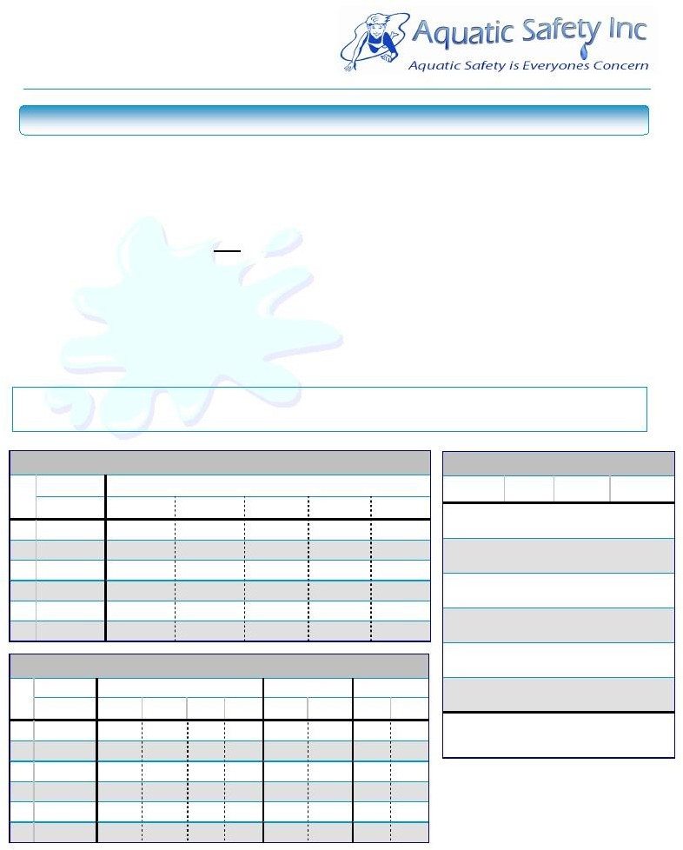
5* Aug 12 Sept 6 Aug 2
6 Sept 9 Oct 3 Aug 30

*Ses #2 & #4 – 1 week of Privates Only classes.
*Ses #5 – Week 4… Sept 2 (Mon) Classes will meet
on Sept 6 (Fri) of that week only.
Family Reg Fee is due with this Form.
- Group Classes $200 per Session (8 classes)
- Private Classes $380 per Session (8 classes)
- 2 Person Privates $480 per Session (8 classes)
- Private Classes Only Weeks – Special Pricing Session #2 – 3 days $135 per student
Session #4 – 4 days $180 per student
- Add on Privates available at a pro-rated basis.

7261 Piute Creek Dr. Corona, CA 92881 (951) 316-8650 AquaticSafetyInc@Aol.com Fax # 1-866-758-9191

Payments Accepted via…
Cash or Check (Steven Nelson)

⇨ Attach your payment to the completed Payment Slip and place in the mailbox located poolside @ the payments table. You may mail it in ahead of time with your Registration Form and Family Registration Fee if you prefer.
Electronic Payment Options PayPal - Venmo - Cash App - Zelle

⇨ Only “Friends & Family” Payments are Accepted. No “Goods & Services” Payments are Allowed, they will be refused and/or returned. If you need help with this, please text me for clarification BEFORE sending ANY payments electronically, or, pay poolside via Cash or Check. Scan the appropriate QR Code below to link to my payment portal. On some phones this may be done directly via your camera, and it will take you to the desired site to pay. On others, you may need to download the desired app and scan the QR Code from within the app. Once payment is complete, fill out the payment slip indicating how & where you paid & place in the mailbox located poolside at the payments table. Make note of the Session # and your child’s name within the app that you use to pay with each Session that you pay for clarity.

Scan to pay with Paypal Enter Phone # in Zelle
951-316-8650

Scan to pay with Venmo Scan to pay with Venmo Session 4 – 7 Only
Session 1 – 3 Only
Scheduling and Programming Information

- Classes are not set up in advance… Once I receive all the Registration Forms, I sit down and create classes based upon age, ability, comfort, your listed availability, and our instructor’s availability. Once students are placed into classes, I text you your actual days and times for that upcoming Session. You must respond to that text to confirm your class information immediately, so your class assignment is saved for you. You must list all of your availability from the beginning… once I start the scheduling process, there is not time for me to re-contact 250 families to see if they have any additional availability because what they listed isn’t an option. The same goes for changes… once I text you your class information, that means the schedule has been set in stone & changes after the fact are almost impossible.

- For Group Classes…. Make-up lessons, refunds and/or credits for missed classes are not provided. Once you commit to a class spot, that spot is reserved for you for that Session. In order to obtain and retain high quality Instructors for you, I guarantee them their hours each Session. As such, your Session payment is not for a guaranteed number of classes, but for a guaranteed spot within that class regardless of your attendance.

- For Private Classes…. There are no refunds and/or credits for missed classes for the same reason as stated above. With advanced notice at the beginning of the Session, I will attempt, but not guarantee, to find you a make-up class for your prescheduled absence. I will text you any options that I find available for a makeup class as the Session progresses. Because I don’t control your schedule or what may or may not become available, I can’t guarantee that a spot will open that works for you.

- On your Registration Form, you will be submitting your request and availability for the Session you wish to start swimming with us. As we schedule each Session separately, you must then fill out and turn in a Session Continuation Form in order to continue swimming into any additional Sessions. Those forms will be available at the payments table (poolside) and placed out the 1st week of each Session to sign up to continue into the next Session. Sessions are separate and as such, class availability may adjust between them so once again, please ensure that you list all of your availability when you fill out the requests.

- Lastly…. The Family Registration Fee ($35 1 student, $60 2 or more students) is due with your Registration Form and is good for the entire summer. The Session cost for your swimmers very 1st Session may be paid in advance but must be paid no later than their 1st day of class. All additional continuing Sessions must have their payments submitted in advance with the Continuation Request Form that you turn in poolside. Payments to secure a space in a continuing class will be refunded If, for some reason, I am unable to find you a class spot in that Session that fits your request and listed availability.

- Clarity is vital. Feel free to make notes on your forms to help clarify anything necessary.

